**Topic: Perimeter, Surface Area and Volume with enlargements/reductions**

Time: 45 mins Marks: /45 marks

**Calculator Assumed**



**Question One: [7, 9: 16 marks]**

a) Consider the figures below.

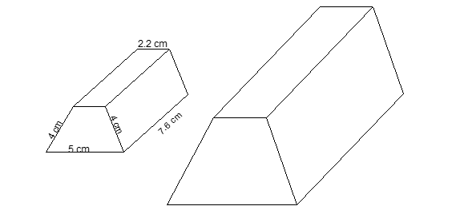

If the smaller prism is enlarged such that the ratio from the smaller to larger is 1 : 3, calculate the surface area of the larger prism.

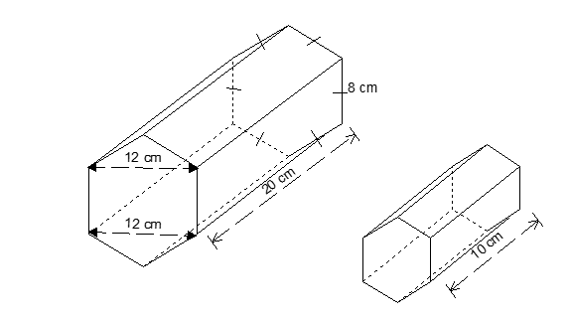b) The following prisms are similar.

i) What is the scale factor used to reduce the larger prism?

ii) Calculate the volume of the smaller prism.

**Question Two: [3, 4, 1, 1: 9 marks]**

The following feature wall with steps appears on plans for Carmela’s new house.

a) Measure the length of the brick wall, from one end to the other including the stairs, and determine its actual length.

The side profile of the wall on the left and right of the steps is the following shape.

In real life this is to be 1.4 m high by 1.8 m wide and the short vertical side is to be 20 cm.

b) If Carmela wants these sides plastered and painted with a metallic paint which costs $120/m2, how much will it cost to paint these two sides?

Carmela’s husband, Tony, decides that the feature wall with steps is not big enough and he wants it 1.5 times bigger.

c) If the builder decides not to redraw the plans but just to modify the scale on the original plan, write the new scale, in the form a : b, to reflect Tony’s demand.

d) How does this affect the surface area of the two sides which are being plastered and painted (from part b)?

**Question Three: [4, 4, 3: 11 marks]**

The following is the shape of a standard brick made by a brick company. It is important for bricks to have holes through them to allow for the natural expanding and contracting which occurs with temperature changes.

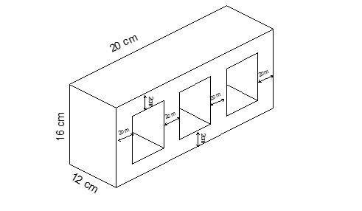

A company offers two sizes for this brick. The standard size, as shown in the diagram above and the miniature size (not pictured).

a) Calculate the total volume of the three air holes for the standard brick size.

b) If the ratio of the miniature brick to the standard brick is 2 : 5, label the diagram below showing all the dimensions of the miniature brick.



c) What is the ratio of the volume of the air holes of the miniature brick to the standard brick?

**Question Four: [4, 5: 9 marks]**

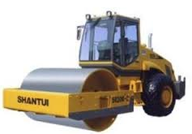Pictured below is a toy road compactor and an actual road compactor. Neither are drawn to scale.

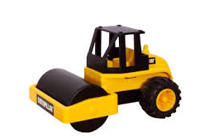

The cylindrical compactor on the toy has radius of 2.5 cm and a length of 9.4 cm.

a) If the toy compactor is covered in paint and is then pushed along for 62 cm, thus painting a 62 cm stripe, how many rotations of the cylinder is this?

b) If the actual compactor is 30 times the size of the toy, calculate the area of road, in m2, the actual compactor would cover, similar to the stripe mentioned in part a.

**Perimeter, Surface Area and Volume with enlargements/reductions SOLUTIONS**

Time: 45 mins Marks: /45 marks

**Calculator Assumed**



**Question One: [7, 9: 16 marks]**

a) Consider the figures below.



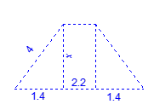If the smaller prism is enlarged such that the ratio from the smaller to larger is 1 : 3, calculate the surface area of the larger prism.





b) The following prisms are similar.



i) What is the scale factor used to reduce the larger prism?

ii) Calculate the volume of the smaller prism.

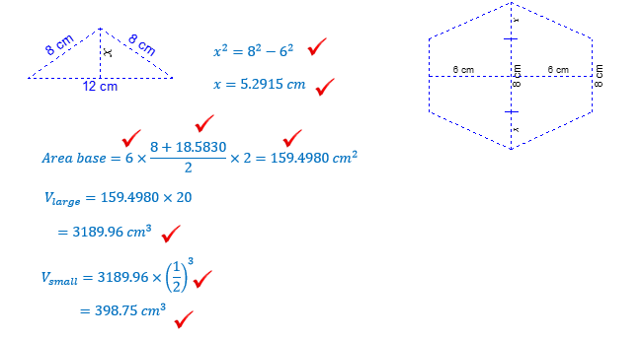

**Question Two: [3, 4, 1, 1: 9 marks]**

The following feature wall with steps appears on plans for Carmela’s new house.

1 cm = 1 m

a) Measure the length of the brick wall, from one end to the other including the stairs, and determine its actual length.

 10.7 cm on drawing

 10.7 m

The side profile of the wall on the left and right of the steps is the following shape.

In real life this is to be 1.4 m high by 1.8 m wide and the short vertical side is to be 20 cm.

b) If Carmela wants these sides plastered and painted with a metallic paint which costs $120/m2, how much will it cost to paint these two sides?





Carmela’s husband, Tony, decides that the feature wall with steps is not big enough and he wants it 1.5 times bigger.

c) If the builder decides not to redraw the plans but just to modify the scale on the original plan, write the new scale, in the form a : b, to reflect Tony’s demand.

 1 : 100 🡪 1: 150

d) How does this affect the surface area of the two sides which are being plastered and painted (from part b)?



SA is 1.52 times larger. $∴$ SA is 2.25 times larger

**Question Three: [4, 4, 3: 11 marks]**

The following is the shape of a standard brick made by a brick company. It is important for bricks to have holes through them to allow for the natural expanding and contracting which occurs with temperature changes.

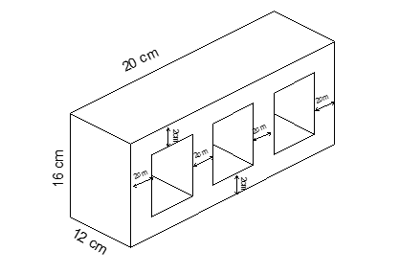

A company offers two sizes for this brick. The standard size, as shown in the diagram above and the miniature size (not pictured).

a) Calculate the total volume of the three air holes for the standard brick size.



b) If the ratio of the miniature brick to the standard brick is 2 : 5, label the diagram below showing all the dimensions of the miniature brick.

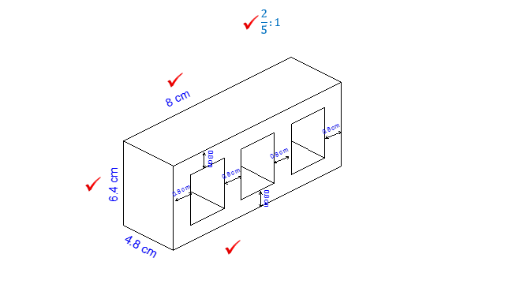

c) What is the ratio of the volume of the air holes of the miniature brick to the standard brick?



**Question Four: [4, 5: 9 marks]**

Pictured below is a toy road compactor and an actual road compactor. Neither are drawn to scale.



The cylindrical compactor on the toy has radius of 2.5 cm and a length of 9.4 cm.

a) If the toy compactor is covered in paint and is then pushed along for 62 cm, thus painting a 62 cm stripe, how many rotations of the cylinder is this?





b) If the actual compactor is 30 times the size of the toy, calculate the area of road, in m2, the actual compactor would cover, similar to the stripe mentioned in part a.



